
Cranfield University presents
High Performance Energy Harvesting Demonstrators
Time: 10:30-15:00
Date: Tuesday 22 May 2012
Location: Building 50, Seminar Room
Cranfield University
Cranfield Campus
Bedfordshire
MK43 0AL UK
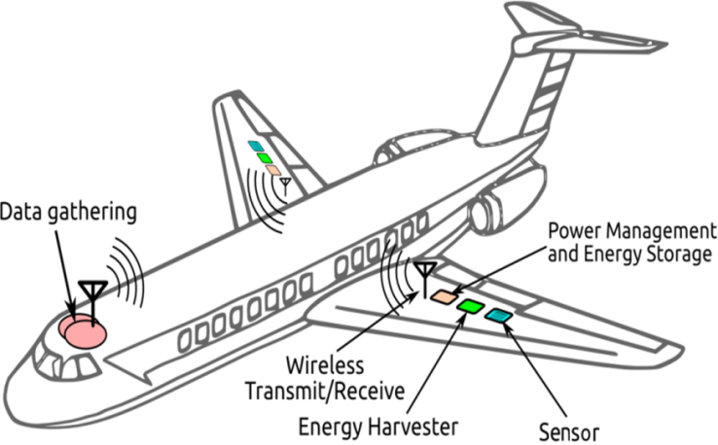



Battery Free Wireless Sensing and Communication Systems
For Structural Health Monitoring

Cranfield University invites you to join us for a one-day event on high performance power harvesting demonstrations for battery-free wireless sensing and communication systems focused on structural health monitoring applications. You will have an opportunity to see energy harvesting demonstrations of Cranfield’s cutting edge research activities in this area.

The event will be specially aimed at the needs of academic and industrial technologists, commercial companies and government agencies who have interests in energy harvesting research and applications for self-power sensors and who seek the deployment of energy harvesting technology for wireless communication sensors systems.

Cranfield University will present their own work on energy harvesting technology with integrated wireless communication sensing systems for structural health monitoring and also would like to discuss with you how the technology can be taken forward and potential collaborations for a wide range of applications.

Agenda
Morning session: Presentations, posters and demonstrations
10.00 – 10:30 Registration & coffee
10.30 – 10:40 Welcome and Introduction
10.40 – 11:20 Development of battery free wireless sensing and communication systems for SHM
11.20 – 11:40 Energy harvesting research overview and questions
11.40 – 12:00 Coffee break
12.00 – 13:15 Poster session (small groups)

12.00 – 13:15 Demonstration of energy harvesting powered wireless sensing systems in the lab (small groups, parallel to the poster session)
- Aircraft wing strain energy harvesting
- Human walking energy harvesting
13.15 – 14:00 Lunch, networking and poster session
Afternoon session: discussions
14:00 –15:00 Discussions and questions
15:00 Close + coffee

To book:
This event is free to attend. If you wish to join us for this event, please send your booking form by 14 May, 2012 to Ms Linda Willsher-Pritchard by email: L.J.Willsher-Pritchard@cranfield.ac.uk , Building 70, School of Applied Sciences, Cranfield University, Cranfield, Bedfordshire MK43 0AL UK, or +44 (0) 1234 758563 or fax +44 (0) 1234 758292.

For further information and discussions regarding this event please contact Dr Meiling Zhu by email m.zhu@cranfield.ac.uk; or T: 01234 750111 extension 2092.

Sponsored by


